FF EAI Robotics
FF Aegis Classic Ultra / Ultra-W
QUADRUPED & WHEELED-LEG ROBOT
User Manual
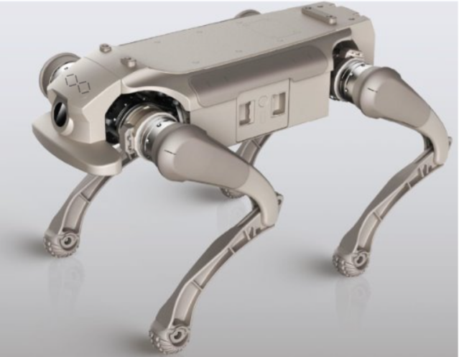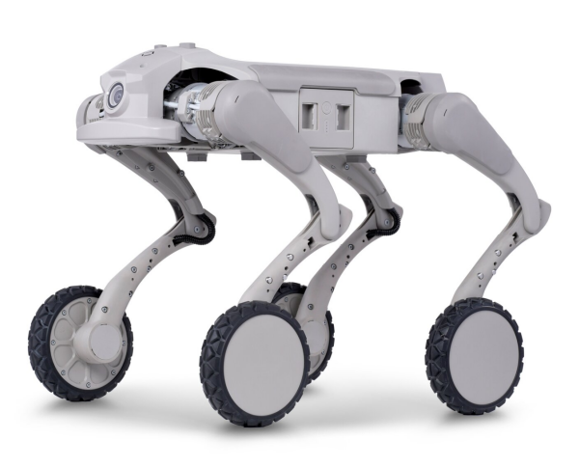

Professional, embodied-AI quadruped and wheeled-leg robot designed for security and companionship

- Legal Statement
- Usage Restrictions & Safety Notes
- Battery and Charging Precautions
- Product Overview & Components
- Power Supply introduction
- Preparation & Remote-Control Guide
- Product Parameters
- Troubleshooting
- Transportation and Storage
- Hazardous Substances Information
- Warranty Information

Legal Statement

Before using this product, users must carefully read the Manual; the quadruped robot is here referred to as the "robot dog", and strictly follow the operating instructions provided herein.

The company shall not be held liable for any property damage or personal injury resulting from misuse or failure to adhere to the guidelines in this Manual. This product consists of multiple components-please ensure that it is kept out of reach of children to prevent accidents. This product is intended for use by individuals aged 18 and above only.

To prolong the service life of the product, do not use it in environments with high temperature or high pressure.

This Manual is intended to provide comprehensive information on the product's functions and usage. However, due to continuous improvements and design updates, there may be discrepancies between the actual product and the descriptions in this Manual. In case of any differences in color, appearance, or other aspects, the actual product shall prevail.

Usage Restrictions & Safety Notes
Usage Restrictions
- This product must not be used by individuals with physical, sensory, or mental impairments, or by those lacking relevant experience and knowledge (including children), unless supervised or instructed by a responsible guardian to ensure safe operation.
- Do not allow children to treat this product as a toy. Supervise children and pets during operation to keep them at a safe distance.
- If the power cord is damaged, it must be replaced with a special cord or component obtained from the manufacturer or authorized service provider.
- Do not operate the product in elevated areas without protective barrier
- If the product exhibits abnormal behavior such as leg flailing or violent shaking, press the Emergency Stop button to activate the soft-stop safety mode. The robot will automatically lie down. Resume operation only after troubleshooting and resolving the issue.
- Do not place the product upside down. Do not use the robot's legs as handles for carrying.
- Do not operate the product in environments above 40°C or below 0°C.
- Do not operate the product in areas with electromagnetic interference.
- Do not operate the product in environments with Wi-Fi or 2.4G signal interference. Before starting the product, ensure there is at least 1 meter of clear space around it, with no people or objects in the motion path, to prevent collisions.
- When the product is ascending or descending stairs or slopes, do not stand below it to avoid injury in case of a fall.
- Do not place children, pets, or any objects on the robot, whether it is in motion or stationery.
- Do not insert hands into the range of motion of the robot's joints during transport, to avoid pinching or cutting.
- Keep body parts away from moving components.
- Power off the robot and unplug the power cord before cleaning or performing maintenance on the robot or charging dock.
- Do not wipe the robot or charge dock with a wet cloth or rinse them with any liquids.
- Do not use third-party batteries, power cords, or charging docks. Only the charging dock included should be used.

Safety Notes
- Joint and Cable Inspection

Check for any foreign objects around the joints, inspect all cables for damage, and ensure that the footpads are intact and undamaged.
- Battery Level and Camera Cleaning

Check for any foreign objects around the joints, inspect all cables for damage, and ensure that the footpads are intact and undamaged.
- Product Cleaning Caution

Do not use alcohol or any liquid containing solvents or corrosive substances to clean this pro- duct.
- Proper Placement and Ground Conditions

When placing the robot, ensure that the legs are in a naturally unloaded state to prevent stress on the joints. Do not rest the robot on hard, sharp, or uneven surfaces to avoid scratching the body.
- Foot Pad Wear

When placing the robot, ensure that the legs are in a naturally unloaded state to prevent stress on the joints. Do not rest the robot on hard, sharp, or uneven surfaces to avoid scratching the body.
- Safe Operation and Terrain Adaptability

Keep the robot within your line of sight and maintain a safe distance from obstacles and potential collision points. Although the robot has good terrain adaptability, always assess whether the surface is appropriate.
- Speed, Turning, and Complex Terrain

Sharp or fast turns may cause loss of control, especially on steep, uneven, or unknown terrain. Avoid risky maneuvers and reduce speed accordingly.
- Steep Slopes and Climbing Angles

Operate within the specified maximum climbing angle. Avoid turning sharply on steep slopes to prevent loss of stability. Exercise caution on steep or inclined surfaces.
- Maximum Speed and Prohibited Usage Environments

The robot can reach speeds up to 8 mph on flat surfaces. Do not use it on complex terrain, slippery surfaces, cluttered areas, slopes beyond specification, or near sharp objects.
- Joint and Battery Condition Check
If you notice loose joints, failure to stand, or excessive noise during operation, stop using immediately, power off the robot, and seek professional service.
- Low Battery Warning
When the battery is low, the robot may not have sufficient power to perform movements. Charge promptly to avoid accidents.
- Safety Precautions
Avoid contact with moving parts to prevent pinching or injury. Do not touch exposed metal surfaces of joint motors during or immediately after operation to avoid bums.
- Heat Dissipation and Cleaning
Prolonged operation may cause motor overheating. Allow the robot to rest periodically. Clean the product promptly if it becomes dirty.

- Power Supply Specifications
Use only fast-charging cables that meet the product's specifications.

- Shutdown Notice
Power off the robot immediately after use.

Battery & Charging Precautions
- Battery Usage Restrictions
Do not disassemble the battery or extract the battery electrodes for use by any means.
- Adapter and Cleaning

Do not clean the power adapter with alcohol or other flammable agents to avoid potential safety hazards.
- In Case of Battery Leakage

If battery leakage causes electrolytes to come into contact with your eyes, avoid rubbing them. Rinse immediately with clean water and seek medical attention promptly.
- Abnormal Conditions

If the battery emits an unusual odor, smokes, deforms, or exhibits other abnormalities during charging, unplug the power adapter immediately and inspect the device.
- Safe Temperature

The power adapter may become hot during charging. Avoid prolonged contact to prevent burns.
- Power Adapter

Do not use a damaged power adapter. Only use the official power adapter. Using unofficial adapters may result in battery leakage, overheating, fire, or explosion.
- Charging Time
The battery charging time should not exceed 24 hours. Overcharging may reduce battery lifespan

Warning：
Any Changes expressly or modifications not approved by the party responsible for compliance
could void the user's authority to operate the equipment.
This device complies with part 15 of the FCC Rules. Operation is subject to the following two conditions:
(1) This device may not cause harmful interference
(2) this device must accept any interference received, including interference that may cause undesired operation.
Note: This equipment has been tested and found to comply with the limits for Class B digital dev
ice, pursuant to part 15 of the FCC Rules. These limits are designed to provide reasonable protection against harmful interference in a residential installation. This equipment generates, uses and ca
n radiate radio frequency energy and, if not installed and used in accordance with the instructions,
may cause harmful interference to radio communications. However, there is no guarantee that interference will not occur in a particular installation. If this equipment does cause harmful interference to radio or television reception, which can be determined by turning the equipment off and on, the user is encouraged to try to correct the interference by one or more of the following measures:
—Reorient or relocate the receiving antenna.
—Increase the separation between the equipment and receiver. FCC
—Connect the equipment into an outlet on a circuit different from that to which the receiver is connected.
—Consult the dealer or an experienced radio/TV technician for help.
FCC Radiation Exposure Statement
This equipment complies with FCC radiation exposure limits set forth for an uncontrolled environment. This transmitter must not be co‐located or operating in conjunction with any other antenna or transmitter. This equipment should be installed and operated at a minimum distance of 20cm between the radiator and your body

Product Overview & Components
FX Aegis Classic Ultra / Ultra-W

12 degrees of freedom (add 4 hub motors for Ultra-W) — full-body articulated quadruped robot.

Supports multiple locomotion gaits and motion behaviors.

Open SDK for motion control algorithm development and communication protocols.

Enables users to conduct secondary development and custom integrations.

Component Highlights

FPV Camera — forward-facing for real-time video

Taillight — status indicator

Expansion Interface — modular payload support

Anti-Collision Head & Tail Hammers — impact protection

Replaceable Battery — hot-swap capable

12 Joints — 3 per leg (hip, thigh, shin)

Anti-Slip Foot Pads (Ultra) / Drive Wheels (Ultra-W) — terrain grip

Protective Rubber Pads — body protection

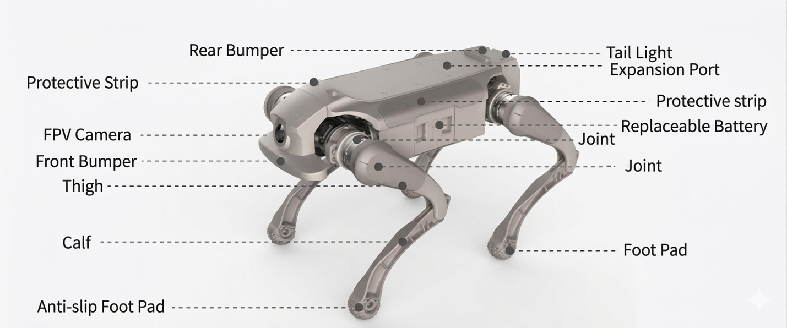

Expansion of Interface Ports
No. | Interface | Qty | Description
1 | Ethernet Port | 1 | RJ45 Interface: Supports 1,000 Mbps transmission for high-speed data communication. Used for network connectivity, remote monitoring, data transmission and other related applications.
2 | USB Port | 2 | Type-A interface: used to connect external storage devices, cameras, sensors, and other USB devices. It provides high-speed data transfer and power supply.
3 | DC Power Port | 2 | Standard DC Power Interface: Provides stable power supply, supporting 12V and 24V voltage outputs, meeting the power requirements of the robotic dog and its mounted devices.
4 | SBUS Port | 1 | Standard SBUS Interface: used to connect remote controller receivers or other communication devices supporting the SBUS protocol, enabling precise remote control command transmission
5 | UART Port | 1 | Standard UART interface: Used to connect embedded systems, communications devices, or other devices supporting the UART protocol. It facilitates data exchange and control between devices through asynchronous serial communication.
Disassembly and installation Method
Use the 2mm hex screwdriver included in the toolkit to loosen the four M4 screws in sequence and remove the cover plate. To reinstall, place the cover plate back and tighten the screws in order.

Description of Lighting Effects
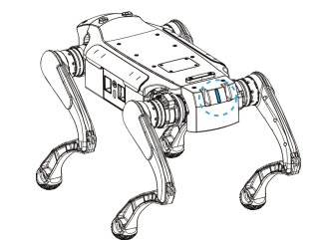
Light Color/Pattern | Meaning
Blue — Always On | Boot complete
Blue — Flashing | Rebooting
White — Always On | Range Mode enabled — improved movement & special skills unlocked
Green — Always On | Tracking Mode enabled
Yellow — Always On | Battery charge is critically low — Rage Mode unavailable
Yellow — Flashing | Battery below 5% charge immediately
Red — Always On | Joints too hot — needs cooling
Red — Flashing | System abnormal — contact after-sales service

Power Supply Introduction
Battery Capacity LED — Idle / Discharge
Battery Display in on State
No. | SOC (%) | LED 1 | LED 2 | LED 3 | LED 4
1 | 0 – 14% | Flashing | OFF | OFF | OFF
2 | 15 – 24% | ON | OFF | OFF | OFF
3 | 25 – 49% | ON | ON | OFF | OFF
4 | 50 – 74% | ON | ON | ON | OFF
5 | 75 – 100% | ON | ON | ON | ON
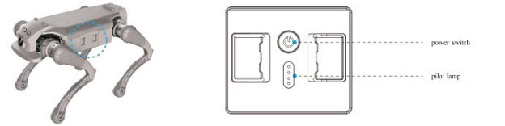Battery Display in charge state
No. | SOC (%) | LED 1 | LED 2 | LED 3 | LED 4
1 | 0 – 24% | Flashing | OFF | OFF | OFF
2 | 25 – 49% | ON | Flashing | OFF | OFF
3 | 50 – 74% | ON | ON | Flashing | OFF
4 | 75 – 99% | ON | ON | ON | Flashing
5 | 100% | ON | ON | ON | ON

Power Adapter
Light off | No Power
Light on | Connect mains power (100V~240V)
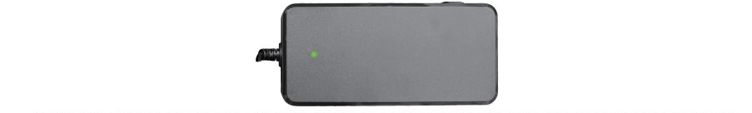
Preparation & Remote-Control Guide
Preparation Before First Use
Start Up

Remove the robot dog from the packaging box and place it on a flat surface.

Take out the battery and insert it into the battery compartment.

Press the battery power button briefly once, then press and hold for 5 seconds to power on.

Wait for the boot sequence to complete (blue LED steady = boot complete).
Shut Down

Ensure the robot dog is in a lying-down position.

Press and hold the power button for over 3 seconds.

Once all LEDs on the battery have turned off, the device is in shutdown state.
Emergency Stop

Press L1 + R1 simultaneously on the remote controller, OR use the Emergency Stop option in the APP.

The robot will activate soft-stop mode and automatically lie down.

Resume normal operation only when it is safe to do so.

Remote Control User Guide
Remote Controller Introduction
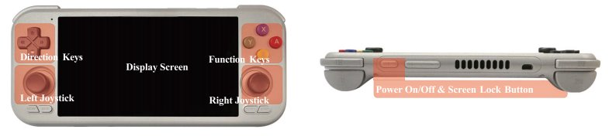
- Press and hold the power button at the top of the remote controller to power on.
- Tap "Smart Robot Controller" to launch the application.
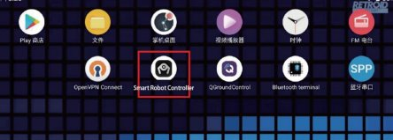
- The APP main page will be displayed.
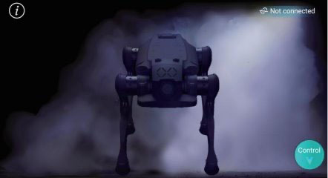
- Tap the button in the upper left corner to enter System General Settings.
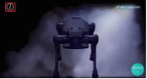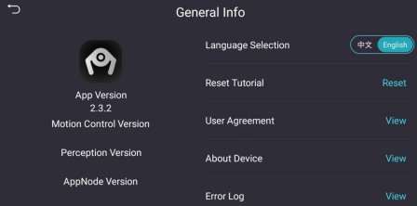
- Tap "Not Connected" in the upper right corner to start the remote controller connection.
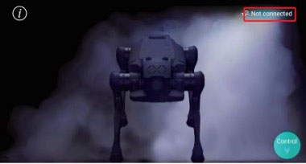
- Select the Wi-Fi network of the robot dog to connect. The Wi-Fi name is found on the device nameplate (format: "XGO13BW001").
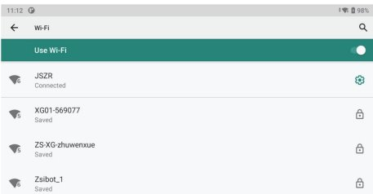
- Connection successful, the APP will confirm pairing.
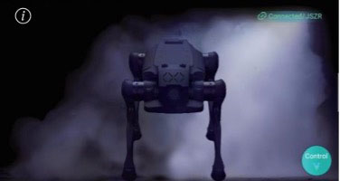

Operations Instructions
Two operating modes: Normal Mode & Laboratory Mode
Normal Mode: Stable movement, standard actions — daily use.
Laboratory Mode: Enhanced performance and unlock addition special actions —— research use and demonstration scenarios.
 | Action | Normal Mode | Lab Mode
Normal/laboratory mode switch |  | App
General Actions | Stand | APP
General Actions | Stand Damping (Slowly Lie Down) | APP
General Actions | Lie Down / Emergency Stop | L1+R1 or APP
Movement actions | Forward / Backward / Left / Right | Forward / Backward / Left / Right
In-place Actions | Idle/Moving Switch | APP
In-place Actions | Pitch Adjustment | Push Right Joystick FWD/Back | Push Right Joystick FWD/Back
In-place Actions | Horizontal Turn | Push Right Joystick L/R | Push Right Joystick L/R
In-place Actions | Left/Right Head Tilt | Y/A
In-place Actions | High / Low Posture | X / B
Special Actions | Jump Up | — | APP
Special Actions | Forward Jump | — | APP
Special Actions | Backflip (Ultra only — not available on Ultra-W) | — | APP
Special Actions | Waving Greeting | — | APP
Special Actions | Biped Standing | — | APP
⚠ Warning:
Special actions in Rage Mode may affect the device lifespan.
Performing special actions in Laboratory Mode imposes heavy loads on the joint modules. Prolonged operation may cause accelerated joint wear and significantly reduce service life.
Please enable with caution and reasonably control the duration of use to ensure long-term stability of the device.

Enable Turbo Mode
- Tap the settings button on the upper left.
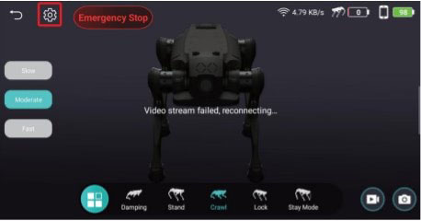
- Enable Turbo Mode.
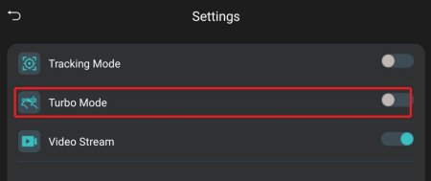

- A Turbo Mode activation prompt will appear. If confirmed, tap “Confirm” to enable it.
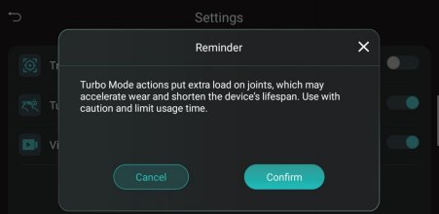
- Turbo Mode Enabled.
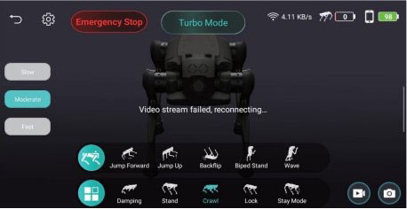

Function description
Basic Control
- Tap the control button in the lower right corner to enter control page.
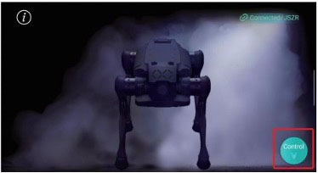
- You can control the robot dog’s movement and posture changes by tapping the center button on the screen, using the virtual joystick, or virtual buttons.
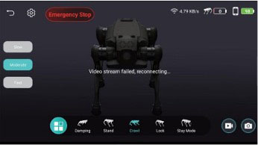

Screen Recording
- Tap the screen recording button in the lower right corner of the screen to start recording.
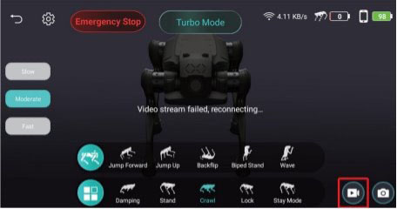
- Recording in progress. Tap the red stop button to end recording.
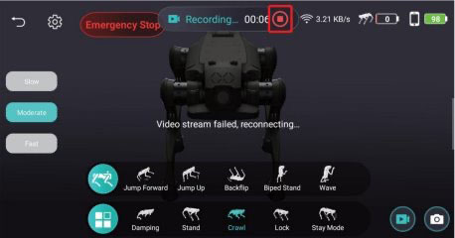
- Recorded videos can be viewed in remote controller’s gallery.
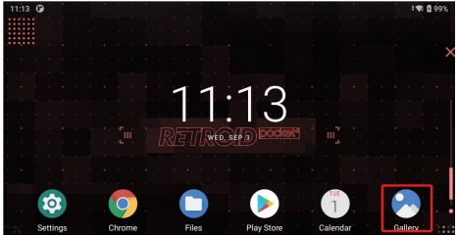
Screen Shot
- Tap the screen recording button in the lower right corner to take a screenshot.
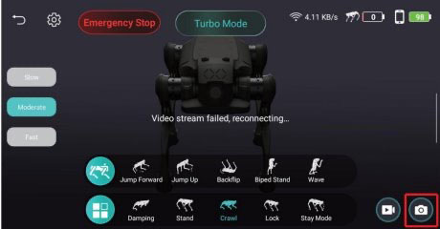
- Screenshots can be viewed in the remote controller’s galley
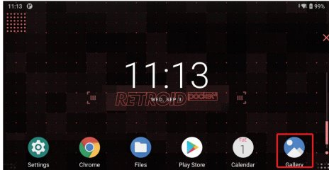

Tracking Function
- Tap the settings button in the upper left corner.
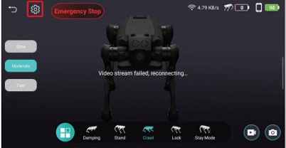
- Select the tracking function.
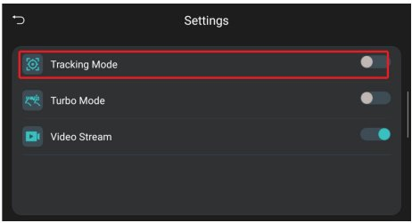
- Red boxes identify all trackable targets. Tap to select a target, then tap “Start Tracking” to activate the tracking function. (once activated, tracking will continue. To avoid accidentally targeting unintended objects, cancel tracking in time.)
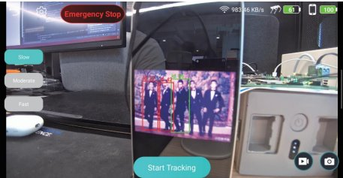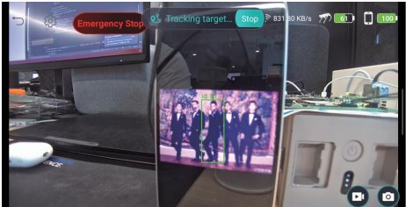
Video Stream Toggle
- Tap the settings button in the upper left corner.
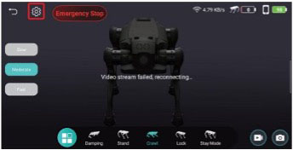
- Select the Video Stream toggle and save the settings.
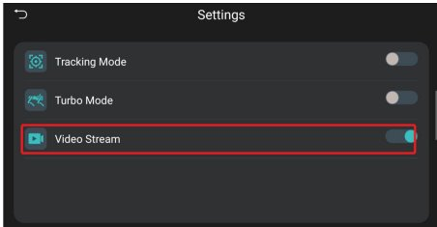

Product Parameters
Category | Specification | Value (US / Metric)
Basic Info | Material | Aluminum alloy + high-strength engineering plastic
Basic Info | Standing Dimensions (L×W×H) | Ultra: 24.8" × 14.2" × 16.5" (630 × 360 × 420 mm)  Ultra-W: 24.8" × 14.2" × 18.3" (630 × 360 × 465 mm)
Basic Info | Lying Down Dimensions (L×W×H) | 26.4" × 17.1" × 5.7" (670 × 435 × 145 mm)
Basic Info | Total Weight (with battery) | Ultra: 35.3 lbs. (16 kg)  Ultra-W: 39.7 lbs. (18 kg)
Basic Info | Operating Temperature | 32°F – 104°F (0°C – 40°C)
Basic Info | Ingress Protection | IP54
Performance | Maximum Speed | Ultra: 8.3 mph (3.7 m/s)  Ultra-W: 12.3 mph (5.5 m/s)
Performance | Effective Payload | 11.0 lbs. (5 kg)
Performance | Continuous Stair-Climbing Height | 6.3 in (16 cm)
Performance | Maximum Climbing Angle | 30° standard / up to 40° maximum
Performance | Vertical Jump Height | Ultra: 13.8 in (35 cm)  Ultra-W: 23.6 in (60 cm)
Electrical | Battery | 4.6 Ah rated capacity, 43.2 V
Electrical | Charging Duration | 1 hour
Electrical | Battery Life (Operating) | 1 – 2 hours
Electrical | Operating Range | 3.7 mi (6 km)

Notes:
1. Charging time is measured at a standard ambient temperature of25°C.
2. Operating range is measured at 1.5 m/s speed under no-load conditions.
3. For details on the expansion of interface usage, refer to the Expansion Interface Manual.
4. For warranty terms, please refer to the Product Warranty Manual.
5. All parameters are based on Laboratory test data. Actual performance may vary depending on the environment and operating conditions.

Troubleshooting
Frequently asked questions | Treatment measure
What if the remote control can't connect to the robot dog? | First, confirm that the robot dog has started, and then confirm that no other version of the APP is running in the background of the remote control. If you still cannot connect to the robot dog, restart the robot dog and the APP and try to connect again.
What if the handle operation of the connected robot dog has no response? | Make sure the handle is connected to the correct Wi-Fi. If it is connected but still cannot control, wait 10 seconds and try again. If there is no response, restart the robot.
Is it normal for a robot dog to stop moving on its own? | It may be that the robot dog’s protection function is triggered. Please wait for 10 minutes and try again. If you still cannot control the robot dog to continue moving, please check whether the battery is sufficient first, and then check whether the handle signal is disconnected.
- Abnormal Conditions
The size of the packing box is 80cm*45cm*25cm. Before carrying the box, please take the battery out of the robot dog. During transportation, be sure to keep the front of the box facing up.
- Storage environment
When storing the power adapter and the entire unit, place them in a dry and cool environment to avoid direct sunlight, fire sources, and strong electromagnetic fields. The recommended storage temperature is between 20°C and 25°C. Do not store the product in environments exceeding 60°C or below-l 0°C. For long-term storage/ it is advisable to maintain the temperature between 20°C and 25°C/ with relative humidity at 0% to 60% RH/ and keep the total battery charge below 50%.
- Battery precautions
Long idle time may affect battery performance, avoid deep discharge to maintain battery state. The battery will stop charging automatically when it is fully charged, but it is recommended to disconnect the connection to maintain the battery state. Please check the battery charge regularly and charge and discharge every 3 months to maintain battery activity. If the charge is less than 20%, it should be charged 40%-60% for storage in time to avoid battery damage.

Transportation & Storage
- Product Transportation
The size of the packing box is 80cm*45cm*25cm. Before carrying the box, please take the battery out of the robot dog. During transportation, be sure to keep the front of the box facing up.
- Storage environment
When storing the power adapter and the entire unit, place them in a dry and cool environment to avoid direct sunlight, fire sources, and strong electromagnetic fields. The recommended storage temperature is between 20°C and 25°C. Do not store the product in environments exceeding 60°C or below-I 0°C. For long term storage/ it is advisable to maintain the temperature between 20°C and 25°C/ with relative humidity at 0% to 60% RH/ and keep the total battery charge below 50%.
- Battery precautions
Long idle time may affect battery performance, avoid deep discharge to maintain battery state. The battery will stop charging automatically when it is fully charged, but it is recommended to disconnect the connection to maintain the battery state. Please check the battery charge regularly and charge and discharge every 3 months to maintain battery activity. If the charge is less than 20%, it should be charged 40%-60% for storage in time to avoid battery damage.
Risk of explosion if the battery is replaced by an incorrect type. Disposal of a battery into fire or a hot oven or mechanically crushing or cutting of a battery. that can result in an explosion. Disposal of a battery into fire or a hot oven or mechanically crushing or cutting of a battery. that can result in an explosion. Leaving a battery in an extremely high temperature surrounding environment can result in an explosion or the leakage of flammable liquid or gas. A battery subjected to extremely low air pressure that may result in an explosion or the leakage of flammable liquid or gas.
- handle gently
After starting up, please avoid lifting or carrying this product. Please be sure to tum off the machine before carrying it. Please handle the parts gently to avoid mechanical impact and damage.

Hazardous Substances Information
Component | Lead (Pb) | Mercury (Hg) | Cadmium (Cd) | Hexavalent Chromium (Cr (VI)) | Polybrominated Biphenyls (PBB) | Polybrominated Diphenyl Ethers (PBDE)
Circuit Board | X | O | O | O | O | O
Metal Plate | X | O | O | O | O | O
Housing | O | O | O | O | O | O
Battery | X | O | O | O | O | O
Other Components | O | O | O | O | O | O
This inspection is based on the provisions of SJ/T 11364.
O = Indicates that the content of the hazardous substance in all homogeneous materials of the component is below the limit requirement specified in GB/T 26572.
X = Indicates that the content of the hazardous substance in at least one homogeneous material of the component exceeds the limit requirement specified in GB/T 26572.

Disposal: This product contains a rechargeable lithium battery pack. It is harmful to the environment when discarded. Remove the battery before disposal and hand it to a professional recycling agency.

- Before removing the battery, please power off the device and deplete the battery charge as much as possible.
- Do not damage the battery casing to prevent potential hazards.
- The removed battery must be handed over to a professional recycling agency for proper disposal
Warranty Information
Component | Warranty Period | Start of Warranty
Whole Machine (Bionic Quadruped Robot) | 12 months | Upon activation (or 90 days after receipt if not activated)
Motherboard | 12 months | Upon activation (or 90 days after receiving receipt)
Joint Module Motor | 12 months | Upon activation (or 90 days after receiving receipt)
Tele controller (Screen) | 6 months | Upon activation (or 90 days after receiving receipt)
Charger | 6 months | Upon activation (or 90 days after receiving receipt)
Battery Cell | 6 months / 200 cycles | Upon activation (or 90 days after receiving receipt)
FPV Camera | 6 months | Upon activation (or 90 days after receiving receipt)

- Battery warranty is a first-to-arrive mode: the warranty period OR the maximum number of cycles — whichever is reached first — ends the warranty.

- The remote control has a handle remote control and a screen remote control, the warranty time is different, the handle remote control is 12 months, the screen remote control is 6 months

Non-Warranty Clause (Exclusions)
- Damage to the robot caused by user's secondary development (including but not limited to: damage caused by high-speed movement of the equipment, damage caused by falling of the equipment, damage caused by changes in the limb parameters of the equipment, etc.);
- Damage caused by hardware modification.
- Unauthorized shell opening.
- Damage caused by force majeure or extreme environment (including but not limited to strong magnetic field / high temperature/ low temperature/ natural disaster);
- Appearance damage, structural parts damage, and internal circuit damage caused by improper use.
- Damage caused by collision and fall.
- Damage caused by liquid and foreign matter entering the machine dog.
- Data security accidents.
- The product is used for illegal purposes (including but not limited to war activities, terror- ism), violates Chinese mainland laws and regulations, violates the laws and regulations ofthe country or region where it issued, violates international conventions, etc., any problems arising therefrom are not covered by the warranty.
- Improper use in the Frenzy mode will result in the loss of warranty for the device (including but not limited to impact damage caused by highspeed movement of the device, fall damage caused by special actions of the device, etc.).

Warranty Support Services
Remote technical support
- Support requirements: equipment serial number, fault description and on-site image data.
- After receiving the request, the technical support will be diagnosed by the front-line engineer and give the diagnosis result and maintenance plan.

Maintenance support
- Repair: For the faulty equipment, you can apply to send it back to the designated maintenance center of our company. If the product quality is detected, the relevant labor costs and spare parts costs will be exempted. If the product is not guaranteed, the corresponding labor costs, spare parts costs, logistics costs and other costs will be charged.
- Maintenance period: 7 working days after receiving the equipment for repair (additional communication is required in special cases).
- Logistics: Whether or not it is insured, the round-trip logistics costs shall be borne by you. The choice of logistics shall be designated by our company. In case of special circumstances, we can communicate with you.
Exception Clause
- The company shall not bear any third-party claims arising from the use of the products in any form.
- The Company shall not be liable for data storage, loss or leakage (customers need to back up by themselves).

